Animals Try It
1. Caring for Pets
Help take care of your pet for a few days. Along with a family member, feed it, brush it, walk it, give it fresh water, or clean its litter box or cage. Don’t forget to play with it gently, too! If you don’t have a pet, pick an animal you’d like to have. Find out what the animal needs to stay happy and healthy.
Naming Your Pet
Do you have a pet dog or cat? If you do, write its name on the line below the picture. If you don't have these pets, make up a good name for each and write it on the line below each picture.
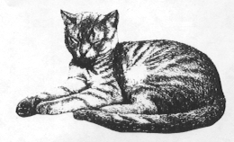 | 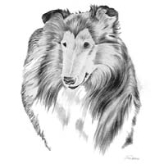
_________________________ | _________________________
2. Understanding Animals
Meeting an Animal
Do you know how to safely meet someone else's pet for the first time? Put a check mark (or an "X") in front of each item that is appropriate.
____ 1. Run up to it.
____ 2. Walk slowly toward it so it can see you.
____ 3. Slap your hands on your lap so it can jump to you.
____ 4. Whistle loudly at it.
____ 5. Run after it.
____ 6. After safely approaching it, gently pet it.
____ 7. Scruff it up behind its ears.
____ 8. Ask the owner its name, and calmly call it by name.
____ 9. Pull its tail to keep it with you.
____ 10. Step on its foot gently so it can't run away.
Which Animals Make Good Pets?
Circle the pictures of animals that would make good pets. Put an "X" through the pictures of animals that wouldn't make a very good pet.
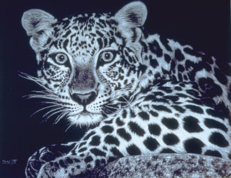 |  | 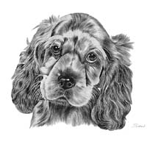 |  | 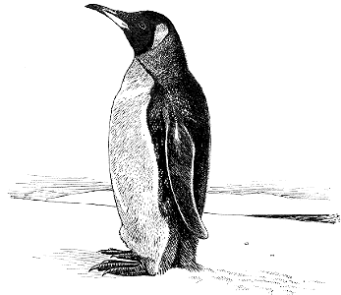
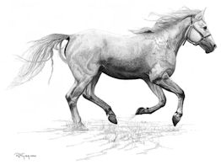 | 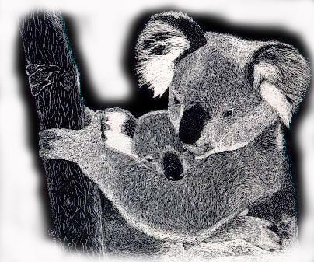 |  | 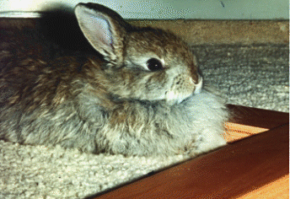 |  | 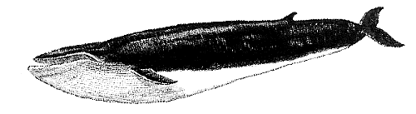

3. Creature Moves: practice moving like the animals
Rabbit Hop: Bend your knees and jump forward
Seal Slide: Pull yourself forward with your hands at your side while dragging your body and feet. Bounce a little if you can.
Elephant Walk: Bend forward. Extend your arms and place one hand over the other to form a trunk. Make sure that your fingers are pointing toward the ground. Move slowly with legs stiff and straight and your trunk swinging from side to side.
Crab Scuttle: Sit on the floor with your hands behind you. Lift up your body with your hands and feet. Walk on all fours. Walk forward and backward quickly.
Inchworm Crawl: Place both hands on the floor. Try to keep your knees stiff and legs straight, but bend your knees if you have to. Walk forward with your hands as far as you can, and then walk forward with your feet to your hands.
Frog Jump: Squat on the floor with hands in front of feet. Jump forward and land on both hands and feet.
Snake Slither: Lie on the floor on your stomach. Keep you arms against the sides of your body. Move your body from side to side and try making an “s” shape.

What to Do If You Find a Baby Bird
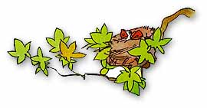
Many baby birds are found by people and taken in to be cared for. People believe the baby bird is rejected by its parents, lost, or cannot get back into the nest. The fatality rate of baby birds that are taken in by kind-hearted individuals is very very high.
Many people ask if a baby bird will be rejected if a person handles the baby and the bird parents smell the human. This is just an "old wives'" tale. Baby birds are NOT rejected by their parents if a person handles them. In fact, most birds have a very poor sense of smell.
Many fledglings are scruffy looking and look like they are unable to be on their own. They may leave the nest, scurry on the ground, etc., looking like a lost baby bird. The parents care of these fledglings and keep track where they are until the fledglings can live on their own. So the baby bird you see may be a fledgling that is being taken care of by its parents still.
If the baby is NOT fully feathered and has fallen from its nest, the very best thing is to put the baby back into the nest. Remember, depending on the age and species, a baby bird may need to eat every 20 minutes during daylight hours. The parents can take care of it so much better than you can, no matter how hard you try.
If the nest has blown out of a tree, you can nail or wire it back into the tree. If you cannot find the nest but know the general area the nest was located, you can take an empty margarine tub or something similar, put some dry grass or a bit of material in it, nail the new "nest" to the tree, and put the baby or eggs back into it. Then leave the baby and nest alone so the parents will come back and take care of it.
DO NOT put the baby or eggs into a new birdhouse and hang it up. If the parents built the original nest in a tree or shrubs, they are not cavity-dwellers and will never find the baby in a birdhouse.
If the parents have not come back after several hours, then give a wildlife rehabber in your area a call, and follow their directions. In Passaic County call: Fran Alala 973-728-2140, George Banta 973-839-0250, or Dolores Garbowski 973-839-4597 or visit http://www.state.nj.us/dep/fgw/98byname.htm.

How To Help An Injured Bird

If you do find an injured bird, carefully pick it up and place it in an unwaxed paper bag or cardboard box that you have lined with tissue or paper towel. Then place it in a quiet, dark place. Make sure that the bird is upright.
If it cannot sit up, create a "donut cushion" out of a piece of tissue and place the bird inside. Find a Humane Society or rehabilitation center that accepts wild birds. Be prepared to transport it there.
Do not give the bird anything to eat or drink. Leave it undisturbed for an hour or two. If after this time it appears alert and unharmed, simply let it out of the bag or box well away from any windows.
Handling causes great stress to the bird, so avoid this if at all possible. If you must hold the bird in hand when you go to release it, do not launch it as this will disorient the bird. Just open your hand and be patient.
If you have any doubts or concerns, call your local wildlife rehabilitation center or Humane Society, or a veterinarian who has some experience with birds.
Cats and pesticides also pose a serious threat to birds. Keep your cat indoors or build screened enclosures for them complete with branches and other perches. (The birds and your cats will be safer!)
Make sure that bird feeders and other attractants (birdbaths, nutritious vegetation) are either less than one meter or more than three meters away from the window. If the attractant is very close to the house, the bird cannot build up enough momentum to injure itself should it hit the window. Alternatively, if the feeder is three meters (ten feet) away, the bird is less likely to come close enough to the house for a collision to take place.

4. Sound Charades – Cut out names, choose one, and don’t tell anyone which you chose. Show other’s who you are but sounding like that animal.

chicken | fly | cricket | horse
donkey | sparrow | lion | frog
elephant | rattlesnake | cow | parrot
alligator | monkey | mouse | owl

