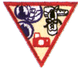
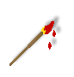
Hobbies
Try-it
Painting
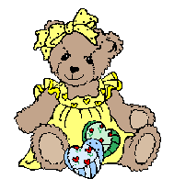
Stuffy’s


Coin
Insects




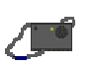
Softball
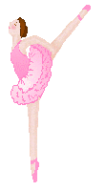
Photography

Soccer

Dance

A hobby is something you like to do when you have some free time. Hobbies can be collecting things, like coins or rocks; making things, like beaded jewelry or clay figures; or doing things like reading or playing soccer. (Try-its for Brownie Girl Scouts pg 36)

After you have completed the following pages, come in and tell the troop about your hobby. Bring something to show.

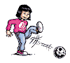
Your Talents, Interests, and Hobbies

- What activities do you like most?
_________________________ _________________________
_________________________ _________________________
_________________________ _________________________
_________________________ _________________________
_________________________ _________________________
_________________________ _________________________

Would these make good hobbies? Yes or No (circle one)

What is your hobby? _________________________________

Discuss your hobby with your family and answer the following questions? Circle the answer

Do you think this hobby will be fun? Yes or No
Can I afford this hobby? Yes or No

Will I have space to do this hobby? Yes or No
Will this hobby hurt the environment? Yes or No
Is this hobby safe? Yes or No
Do I have enough time for this hobby? Yes or No

3. Organize your hobby.
Take time with your family to organize your hobby. If your hobby is collecting, organize and label it. You can use egg cartons, shoe boxes, a decorated box, etc. If your hobby is a sport put together all your sports stuff and organize your trophies, team shirts, balls, bats, gloves, etc. Use a sport bag, back pack or something of the sort to keep your stuff in. Display your trophies, team shirts, etc.

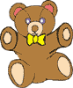
Types of Hobbies

Make a list of things you can collect
______________________ ______________________
______________________ ______________________
______________________ ______________________
______________________ ______________________
______________________ ______________________

Make a list of sports hobbies:
_____________________ ______________________
_____________________ ______________________
_____________________ ______________________
_____________________ ______________________
_____________________ ______________________

Make a list of hobbies that involve making things
______________________ ______________________
______________________ ______________________
______________________ ______________________
______________________ ______________________
______________________ ______________________

4. Practicing your hobby
Keep track of when and what you do with your hobby. Teach it to a friend or family member.
Sunday _____________________
Monday_____________________
Tuesday_____________________
Wednesday __________________
Thursday____________________
Friday______________________
Saturday____________________

